**Mikhail Gorbachev**

**米哈伊尔·戈尔巴乔夫**

(英文部分选自经济学人20220903期讣告)

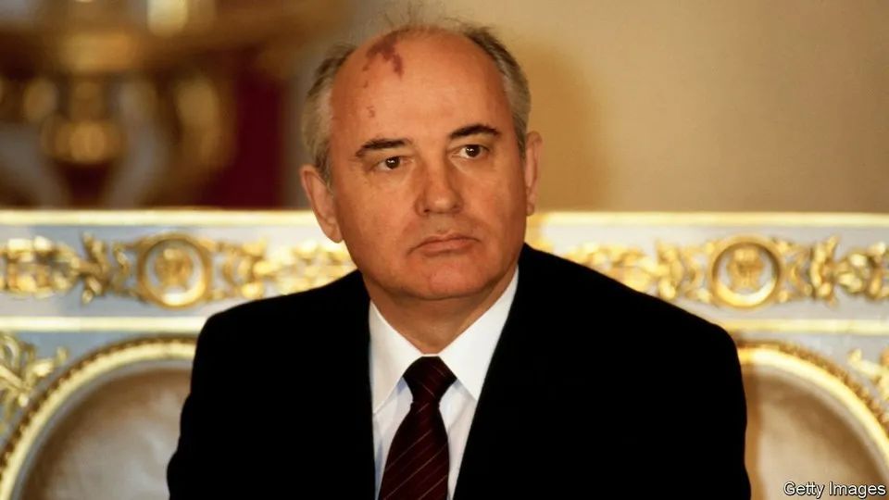

**Mikhail Gorbachev has died**

**米哈伊尔·戈尔巴乔夫驾鹤西去**

The last leader of the Soviet Union was also the architect of its dissolution

苏联末代领导人一手造成苏联的解体

The two great heroes in Mikhail Gorbachev’s pantheon were 19th-century **socialist thinkers**, Alexander Herzen and Vissarion Belinsky, whose main concerns were the dignity of the individual, and whose books he knew almost by heart. When they appeared on the Russian stage, in Tom Stoppard’s trilogy “The Coast of Utopia”, he went to see them. At the end of the performance he was called on stage and given a standing ovation by an audience that, for the most part, had scarcely been born when, in 1985, he became the last general secretary of the Soviet Union.

说起戈尔巴乔夫最崇拜的人，就不能忽略亚历山大·赫尔岑和维萨里昂·别林斯基这两位十九世纪的伟大**社会主义思想家**。强调个体的尊严构成了这两位思想家的理论核心，戈尔巴乔夫对此二位的著作也是谙熟于心。后来，汤姆·斯托帕德三部曲剧作《乌托邦彼岸》将这两位英雄搬上了舞台，戈尔巴乔夫也前往剧场观看。表演结束时，戈尔巴乔夫被叫上舞台接受观众的起立鼓掌欢呼，而其中大部分观众在他1985年成为苏联最后一位总书记时还没有出生。

The perestroika(“restructuring” or “reformation”) which he started then never reached the destination he wanted, a democratic, humane socialism—perhaps because that destination was Utopia, rather than a real place. To the elite of modern Russia, he seems an oddity if not a traitor: a fool who brought about the collapse of the Soviet Union and **made no money out of it**. He had power, a comfortable life and the fate of hundreds of millions of people in his hands—and he let it all go when, on December 25th 1991, he resigned as president of the Soviet Union.

戈尔巴乔夫发起的改革未能实现自己的理想——建立一个民主、人道的社会主义国家。或许他太理想主义了，那种社会只存在于乌托邦之中。以当代俄罗斯的精英的视角来说，即便戈尔巴乔夫不是一个叛徒，也可以算是个怪胎：他是一个傻瓜，弄垮了苏联却**未曾从中捞到任何好处**。他曾经大权在握，生活优渥，掌管着亿万民众的命运；然而这一切都随着他在1991年12月25日辞去苏联总统职务时烟消云散。

He had spent eight hours in a meeting with Boris Yeltsin, Russia’s president and his bitter rival, discussing the transfer of power. Afterwards, he went to lie down in his office—for the last time. When Alexander Yakovlev, his closest comrade, walked in, he saw tears in Mr Gorbachev’s eyes. “You see, Sasha,” said the president, “this is how it goes.”

戈尔巴乔夫和自己的宿敌俄罗斯总统鲍里斯·叶利钦长会谈长达八个小时，讨论如何进行权力移交。在此之后，他生平最后一次走进他的办公室躺下。他最亲密的战友亚历山大·雅科夫列夫走进来时，看见戈尔巴乔夫眼中闪着泪光。戈尔巴乔夫对他说到，“萨沙（亚历山大的小名——译者注），你看，一切都木已成舟”。

He did not mean the Soviet Union to die like that. The man who ended the cold war, who changed the course of 20th-century history, was neither a dissident nor a revolutionary. He intended to reform the Soviet Union, not destroy it. But his aversion to violence and his belief in the Enlightenment were enough to finish a system held together by repression and lies.

戈尔巴乔夫并不想让苏联以这样的方式解体。他结束了冷战，改变了二十世纪历史走向，但是他既非持不同政见，也不是想要革苏联的命。他想要改革苏联，而非毁灭苏联。但是他对暴力的憎恶和对“启蒙运动”的坚信，足以让一个靠镇压和谎言维系的政体土崩瓦解。

He was born in 1931, soon after Stalin had seized complete power and launched the collectivisation which would eliminate the peasantry. He grew up in the south of Russia, a rich agricultural region inhabited by Cossacks who had never known serfdom, in a village called Privolnoye, which means “free-willed”. One of his grandfathers hung Orthodox icons; the other preferred portraits of Marx and Lenin. **Like many of his generation**, he preserved a peasant’s common sense, caution and conservatism. He also had the physical strength of someone who had worked the land from an early age.

戈尔巴乔夫出生于1931年，当时斯大林刚刚全面掌权并开始推行农业集体化，消除个体农户。戈尔巴乔夫成长于苏联南部的普利里沃利诺耶（意为“自由意志”），这是一片富饶的农业区，定居于此的哥萨克人对农奴制一无所知。他的祖父和外祖父家信仰不尽相同，一家是虔诚的东正教徒，一家则更拥护马列主义。**与他那一代的许多人一样**，戈尔巴乔夫身上保有着农民身上的很多特质，他审慎保守，依赖常识进行决断，而且由于从小就开始下田劳作，他也拥有一副强健的体格。

注释：1. 斯大林在1924年掌权后，便推动了一项急速工业化的计划，目标在于赶超西方的工业化国家。食物在其计划中占有核心地位。当时，苏联是主要的谷物输出国，而且，它打算增加这类出口产品的数量，借以筹措资金，向外国购买工业机械。农业集体化于1929-1932年在苏联主要谷物区（乌克兰、北高加索、伏尔加河、南乌拉尔、西西伯利亚）实施，而在其他地区（北部、中亚等），集体化持续了更长的时间（20世纪40年代结束）。从历史角度来看，集体化为苏联工业发展提供了资金，但是给苏联农业和农民带来了深重灾难。https://zhuanlan.zhihu.com/p/4642077762. common sense: sound and prudent judgment based on a simple perception of the situation or facts (via: Merriam-Webster)

It was those sensibilities and human instincts that, years later, allowed Ronald Reagan to see in Mr Gorbachev not just a Marxist-Leninist, but a man with whom he had a lot in common. Both were self-made men who started in small farming communities, both believed in decency, both embodied the optimism and confidence of the post-war years.

多年以后，正是这些源自人性深处的本能和情感让里根意识到，这位苏联的总统不只是一个马列主义者，他和自己有很多相似之处：他们都是出身农家的草根，有共通的是非观，对于战后局势保持乐观，充满信心。

注释：have a lot in common:to share interests, beliefs, attitudes, opinions, etc.The end of the cold war was determined as much by this affinity as it was by the inadequacy of the Soviet economy. Mr Gorbachev, who was more concerned with improving the living conditions of his countrymen than with the status of a superpower which he took for granted, saw no sense in carrying on with an arms race.

这种共情之感无疑对冷战的结束起了关键性的作用，当然冷战结束跟苏联的惨淡经济也脱不了干系。对于戈尔巴乔夫而言，民生远比本国超级大国的地位（他将这一地位视为理所应当）重要，因此完全没必要继续这场军备竞赛。

It was the logical conclusion of a journey that began with the death of Stalin. When Nikita Khrushchev denounced Stalin’s cult of personality in 1956, Mr Gorbachev was one of the young party leaders who had to spread the message among rank-and-file Communists. Clearing socialism of the distortions of Stalinism was to be his life’s work. He came to power with no plan or programme of reforms: only, after 18 years of stagnation, the simple conviction that “We can’t go on living like this.” Instead, he offered the Soviet Union youth, energy and—freshest of all—humanity.

后斯大林时代的美苏冷战走向这样的结局合情合理。1956年赫鲁晓夫清算斯大林在任期间大搞个人崇拜之时，戈尔巴乔夫正是积极在广大党员中宣传“去斯大林化”政治理念的一位党内年轻领导人。事实上，消除斯大林主义对他信仰的社会主义理想的扭曲贯穿了他的一生。戈尔巴乔夫刚执政时并没有任何改革计划，如果说有的话，那就是在经济原地踏步18年之后，他振臂高呼“我们（苏联人）不能再继续这样的生活了”这一纯粹的信念。戈巴乔夫时代的苏联展现出了年轻活力以及前所未有的人性光辉。

After just a year in power disaster struck: a nuclear explosion in Chernobyl. The accident, which the government tried to **cover up**, epitomised its dysfunction, arrogance and disregard for human life. Mr Gorbachev, seizing his chance, condemned a system “penetrated by servility, bootlicking, persecution of those who think differently, window-dressing, personal connections and clans.” In its place he offered glasnost, openness. This, he told colleagues, was the true socialism.

戈尔巴乔夫刚执政一年，一场灾难犹如晴天霹雳：切尔诺贝利发生核爆炸事故。当时的政府试图掩盖事故真相，但却欲盖弥彰，这恰恰反映出政府的失能、傲慢和对生命的漠视。戈尔巴乔夫抓住这一时机，谴责体制中“充斥着奴颜媚骨和迫害异己的思想，弄虚作假的手段不胜枚举，各种拉帮结派层出不穷。”戈尔巴乔夫则倡导公开透明的政策（glasnost）。他告诉同僚们，这才是真正的社会主义。

注释：如果你想了解戈尔巴乔夫的公开性原则 <https://www.doc88.com/p-5186377613392.html>

In that spirit, in 1989 he declared the first ever competitive elections to the Supreme Soviet. He also agreed that its proceedings should be televised for the first time. Millions of people saw Andrei Sakharov, a dissident physicist whom he had recalled from exile, openly challenge Mr Gorbachev. In those few days the political monopoly of the Communist Party was broken, along with the mystery of its power.

秉持着这种精神，1989年他破天荒地宣布通过差额选举的方式产生苏联最高苏维埃，并首次对选举过程进行电视转播。数百万人亲眼目睹戈尔巴乔夫召回的流亡异见物理学家安德烈·萨哈罗夫（Andrei Sakharov）（后者还参加了选举），与戈尔巴乔夫同场角逐。几天后选举结果揭晓，xx党不再一家独大，随之被打破的，还有它的权力之谜。

This was also a signal to all its parts that the Soviet Union was dissolving. In early 1991, desperately trying to hang on to the country, he fatally aligned himself with the forces of repression, sending Soviet tanks into Lithuania. A few months later the same kgb-led forces mounted a coup and put him under house arrest in Crimea, where he was on holiday. When the putsch collapsed and he returned to Moscow, he chose to go home to care for his wife Raisa, who had suffered a stroke, rather than to play a public politician.

而这无异于在向苏联的各个成员国广播——苏联正在解体。1991年初，戈尔巴乔夫拼命想要保住苏联，不惜与镇压武装合作，苏联的坦克开进了立陶宛，这成为了压垮苏联的最后一根稻草。几个月后，同样是由克格勃领导的一支部队，发动政变软禁了正在克里米亚度假的戈尔巴乔夫。政变未遂，戈尔巴乔夫回到莫斯科，但他选择从政治舞台谢幕，转为专心照顾家中中风的妻子赖莎。

**In his unconcealed affection for his wife**, Mr Gorbachev violated the code that demanded of Russian rulers a complete abnegation of private life. But then again, putting private life above the ephemeral interests of the state was his main credo. Leaving office was not the end of his life, as it had been for most of his predecessors. And unlike his successors he had nothing to fear, no wealth to hide. In the first years after his resignation he did commercials for Pizza Hut to make money. By the standards of today’s Russian elite, he was a poor man. The money from his 1990 Nobel peace prize was used to set up Novaya Gazeta, Russia’s liberal newspaper.

**他对妻子毫不掩饰的爱**，和俄罗斯统治者（不成文）的规矩背道而驰。长久以来，私人生活都视为是领导者需要割舍的部分。而对于戈尔巴乔夫而言，家庭永远是第一位的，这远比飘忽不定的国家利益重要的多，这一点他一直深信不疑。和大多数以前的领导人不同，他是主动退位的。但和之后的继任者不同的是，他无所畏惧，也无财可匿。辞职之后的头些年，他为赚钱曾给必胜客拍过广告。依照今日俄罗斯精英的标准，他是个穷人。1990年他获诺贝尔和平奖，并将得到的奖金用以创办俄罗斯自由派报纸《新报》（Novaya Gazeta）。

When Raisa was diagnosed with leukaemia, he accompanied her to a German clinic to hold her in his peasant’s arms. Soon after burying her, he appeared at a backstage party at the Moscow Art Theatre. An actor called on the ex-president to read or sing something. Everyone froze with embarrassment, except Mr Gorbachev. The crowd gave him space, and he sang Lermontov’s poem, “Alone I set out on the road. The flinty path is sparkling in the mist.”

妻子赖莎后来确诊罹患白血病，戈尔巴乔夫陪同她前往德国的诊所治疗。他把她搂在自己健壮的臂弯里。妻子去世后不久，在莫斯科艺术剧院后台的一个派对上，一位演员突然请这位前总统上台吟唱诗曲。在一片错愕之中，戈尔巴乔夫来到观众为他腾出的一个位置，吟唱起了莱蒙托夫的诗： 我孤身上路，燧石小道在薄雾中闪烁。